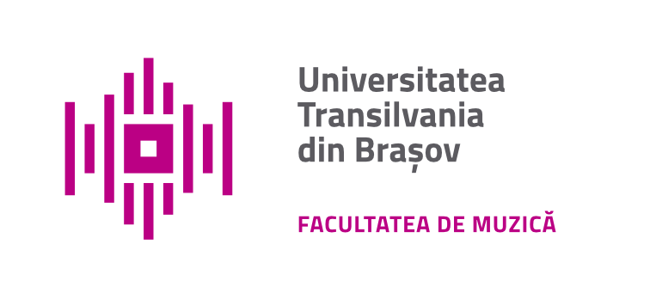
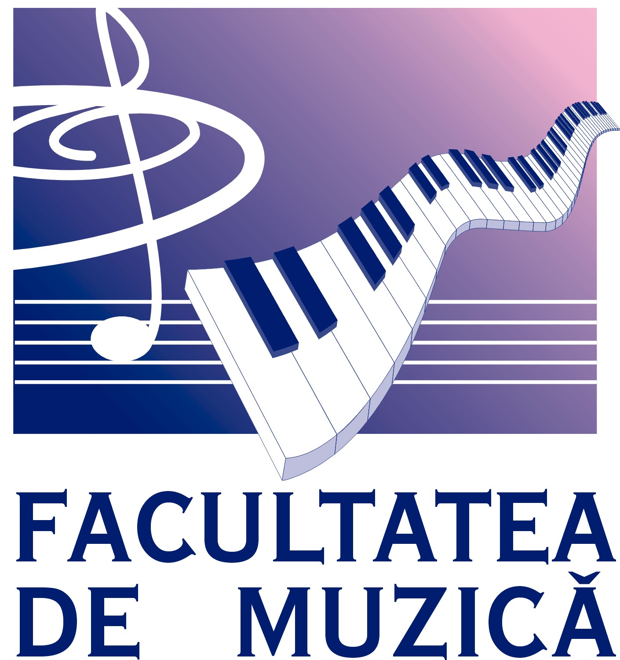
TRANSILVANIA University of Braşov,
Faculty of Music,
Romania

International Conference

THE SCIENCE OF MUSIC – EXCELLENCE IN PERFORMANCE
14th Edition
8th – 11th of November 2024

- Registration form and Abstract submission - DEADLINE: 1st September 2024 (braconfmusic@yahoo.com)

- Last Name, First Name
- Affiliation/Institution
- Department
- Country |  | City
- Phone
- E-mail

- Type of participation |  | In person presentation  Virtual presentation (for authors who will not be attending in person)

PAPER DETAILS
- Title

- Abstract (max. 10 lines)

- Keywords

- Brief biography/ CV (max. 5-6 lines)

